Configuration of MariaDB for DoubleClue Enterprise Management

# Introduction

MariaDB is a popular open source SQL database. It can be used as an external database for DoubleClue.

Please be aware that this is a third party software that is not part of the DoubleClue Enterprise Management! The installation of new MariaDB versions may be different from the one described below!

Tested with MariaDB 10.3 for Windows systems.

# Installation

1. **Go** to [**https://mariadb.org/**](https://mariadb.org/) **and select download the latest “Stable Version”.**
2. After having downloaded the file, start the “**msi**”.
3. 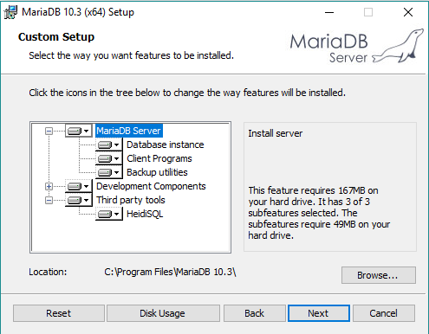In the “Custom Setup” of MariaDB, we suggest installing all components displayed.
4. In the “**User settings**” enter a password for the “root” user and enable the check boxes “Enable access from remote machines for ‘root’ user” and “Use URF8 as default server’s characters set”.

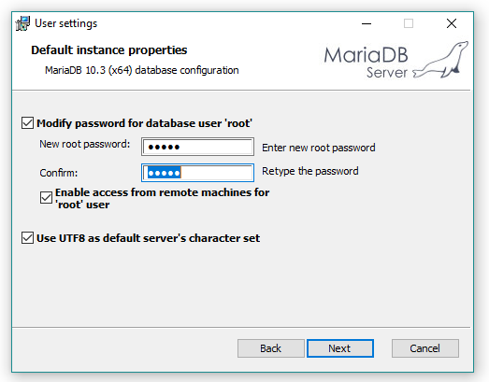

1. The network port for the network communication is “**3306**” by default. If this port is not available on your machine, then you have to change the port. Leave all other settings as default.

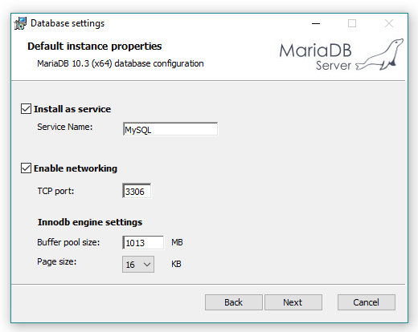

1. The database is now successfully installed.

# DoubleClue Setup

1. 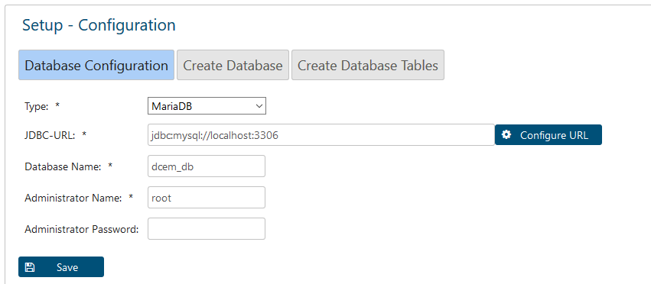Choose MariaDB as Type during the DoubleClue Setup Configuration and enter the administrator password you choose during the installation of MariaDB.
2. If you don’t have created a schema yet, create one in the next step.

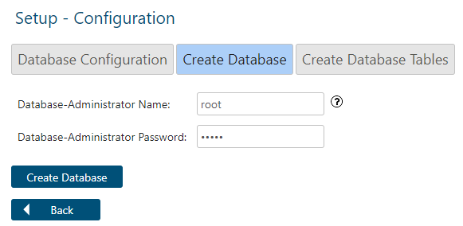

1. Add a Create-Tables Administrator Password if you wish to use one. Then enter the SuperAdmin password you want to use to log into your DoubleClue account.

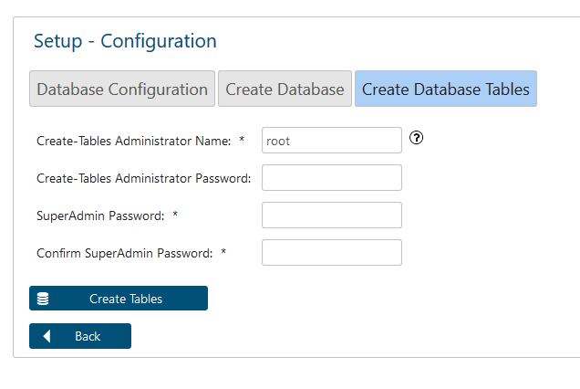

1. Create the tables and complete the setup.